**Sphera Web-Cloud UTI Interface**

**Accident Incident Reporting Module: User Guidance**

**Introduction**

The following instructions will help you to log in and navigate the two main user module screens, create your own personal incident view, enter review and edit an incident.

**Log on details (Authorised Users only)**

To log into the Sphera Web-Cloud UTI Interface incident module please follow this link:

<https://cityofbradford.spheracloud.net/logon.aspx>  
You can also copy and paste the above link in your internet browser and click return.

**Please Note** - This software works best if you use the latest version of Internet Explorer, Google Chrome or Mozilla Firefox.

**Stage 1. Log on Screen**

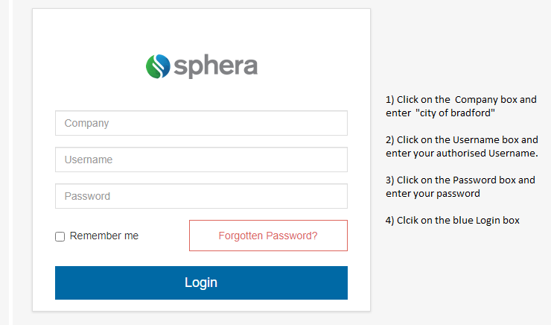

**Stage 2. Use the Header bar**

At the top of every page is the Header bar. The Header bar allows you to easily navigate to different modules, access the Help, and set your user preferences. The Header bar also displays your username and the company where you are currently logged in.

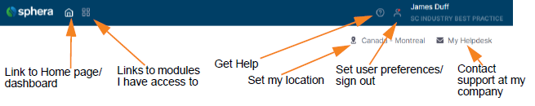

**Stage 3. Open modules from the Header bar**

From the Header bar, click the ‘**Modules**’ icon.

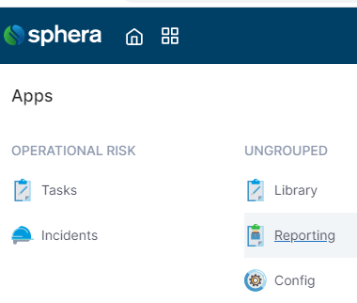

A list of the modules you can access is displayed.

Click the module you want to open.

Note: Clicking ‘**INCIDENTS**’ will take you straight to your summary or created favourite incident view

**Stage 4. Getting Started page**

You should only have to do this the first time you log in to the new version of this software.

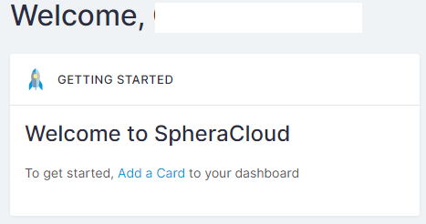

Click on ’**Add a Card**’.

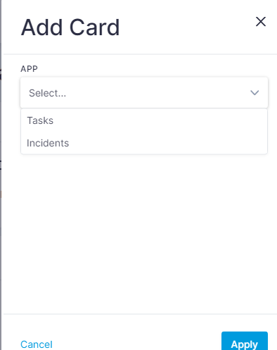

Select‘**Incidents**’then click the blue ‘**Apply**’ icon.

This should give you a new ‘**Dashboard Card**’ with summary details.

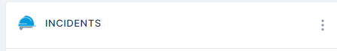Click on the word ‘**INCIDENTS**’ to the right of the safety hat icon - this should now take you to the ‘**Summary**’ view of your reported incidents.

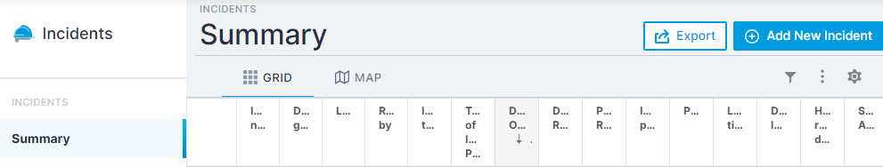

The ‘**Summary**’ view shown may be difficult to read depending on your monitor size, so it is worth spending a little time creating a personal view and setting it as your favourite. Each time you log on in the future and click on to the Incidents page it will take you to ***your chosen view*.**

**Stage 5. Creating a Personal View from the Summary View**

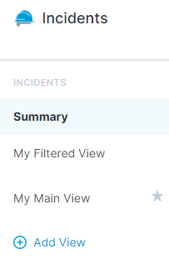

Click on ‘**Add View**’ in blue left side of screen

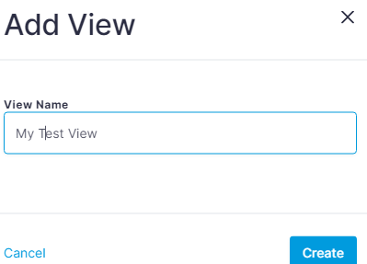

Give the view a name in the box shown and then click on ‘**Create**’ - you should now have a new summary version of the reported incidents

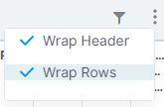

To customise this view, first click the **3 vertical dots** to the right side of the main screen now click both ‘**Wrap** **Header**’ and ‘**Wrap Rows**’ as shown, as this will make the text easier to read.

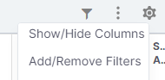Click on settings ‘**cog**’ to the right of the 3 dots and select ‘**Show/Hide Columns**’

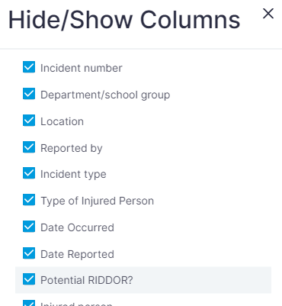

Now de-select the columns you do not want, leaving the ones you want to see in your view and then click ‘**Apply**’. The summary view is defaulted to show all columns.

**Note:** The more columns you have on your view, the less you will be able to read as single row.

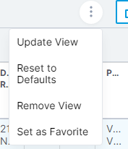Once happy with your column selections click on the **3 vertical dots** on the left-side of the blue box with ‘**Export**’ written on it Select ‘**Update View**’.

**\*\* Remember to update view every time you alter your personal view \*\***

Click on the same **3 vertical dots** to set this view as your favourite and click ‘**Set as Favourite**’ then when you return to the incident screen or the next time you log on it will default to this view.

**Stage 6. Incident “Grid View“**

The actual grids (incident rows) work in the same way as the previous version of the report module e.g. viewing them sorting, shuffling etc. You can filter them down to show what you want to see or review.

Click on the grey icon that looks like a syphon/filter on right hand side of the main screen to open the new menu.

Set what filters you want and then click ‘**Apply**’. This should show the incidents within your set filters e.g. *dept*., *service* or *date range*.

If you want to clear the filters click on ‘**Clear Filters**’. To hide the filter menu click on the syphon/filter icon.

**Stage 7. Adding an New Incident**

To add an new incident on to the incident module, go the **Incident Summary** view or your **Favourite View** and click the ‘**Add New Incident**’ button on the right hand side of the screen.



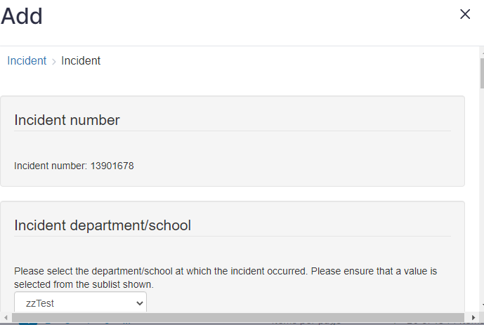A new incident form should be displayed in the centre of the screen as shown below.

Persons reporting an incident should enter **as much information as possible**, completing all the mandatory fields (Yellow coloured boxes) and the non-mandatory boxes (White coloured boxes). Some information fields are drop boxes and others are free text. Additional documents can be uploaded to the incident form.

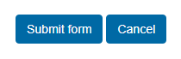

Once complete please click on ‘**Submit form**’.

**Stage 8. Viewing and editing reported incidents**

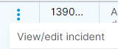To view a reported incident form your screen, click on the **3 vertical dots** on the first column of the incident row.

Click on ‘**View/edit incident**’ from the dropdown menu and it should open the incident form

**OR…**

Click on the blue **Incident Number** and again it will open the incident form.

Review and edit the incident and remember to click on the ‘**Submit**’ bottom at the bottom of the incident form to save the changes made.

**Stage 9. Viewing other incident pages**

To view subsequent pages of reported incidents click on the **page number** or **arrows** to navigate between incident pages.



**Stage 10. Log out**

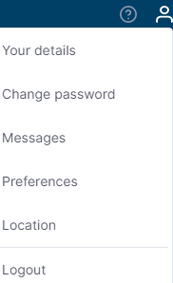

To log out of the system click on your ‘**person**’ icon at the top right of the navigation bar.

Then select ‘**Logout**’ from the menu.

If you have any problems and or concerns then please contact the **Occupational Safety Team**: [Occupational.safety@bradford.gov.uk](mailto:Occupational.safety@bradford.gov.uk)